Run GUI and the following window will pop up:

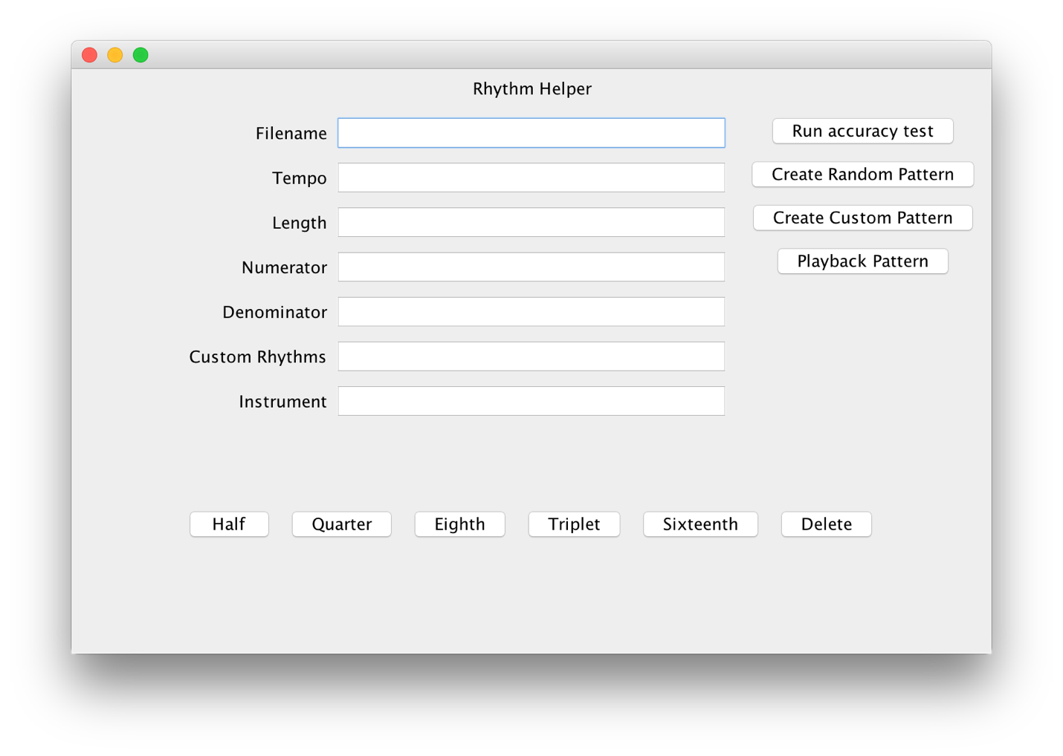

To run any of the functions, you must type a filename. The accuracy test and playback functions only require a filename to run. Creating a new random pattern requires the tempo, length, numerator, and denominator, and instrument, and creating a new custom pattern requires all fields to be filled.

If any required fields are not filled correctly, there will be an exception when running the function and nothing will happen in the GUI. The required types are

Filename - string

Tempo - double

Length - integer

Numerator - integer

Denominator - integer

Custom Rhythms - Comma separated list of doubles, such as "0.5,0.5,1.0,2.0"

Instrument - integer

Creating a new pattern should open a window like the following that details the notes in that new file:

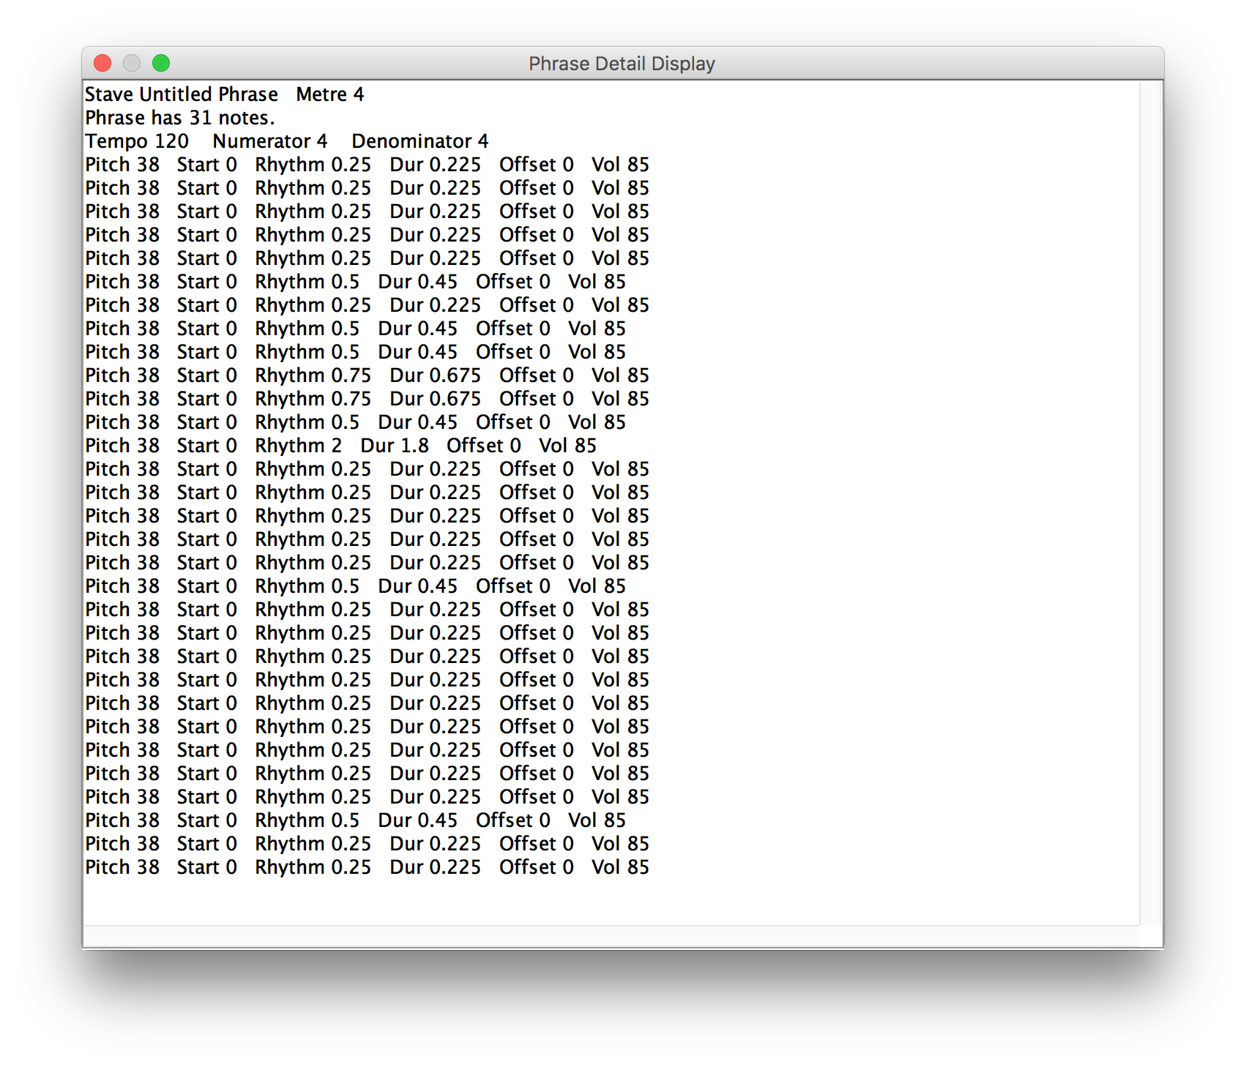Once you close this window, the file will be created with your given file name:

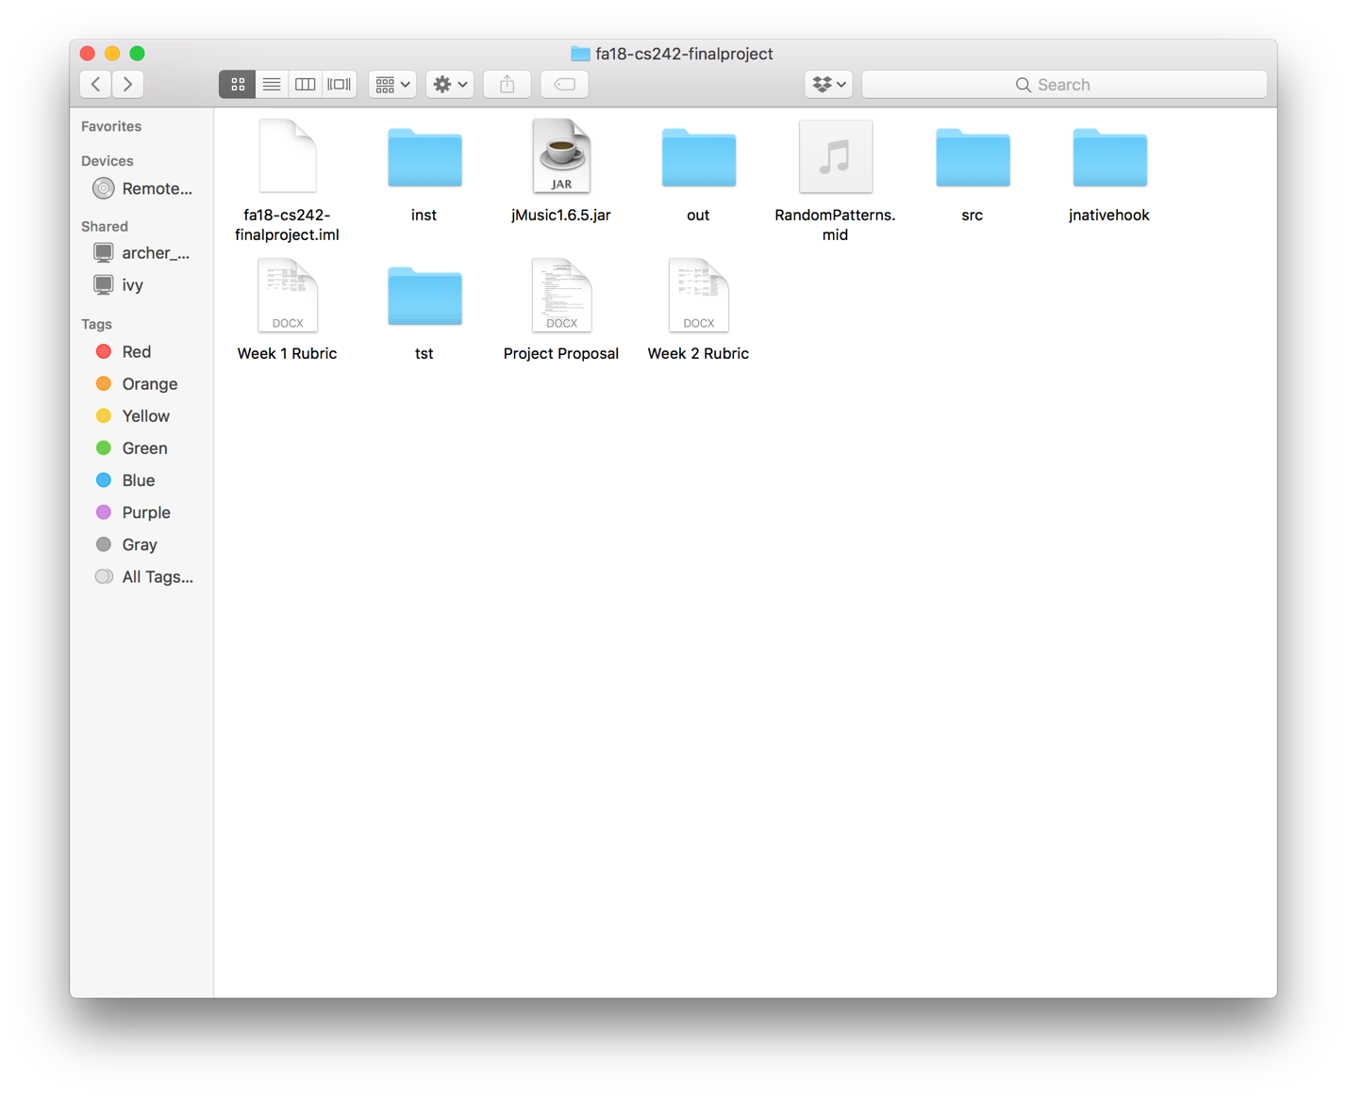

Opening that file should look something like this:

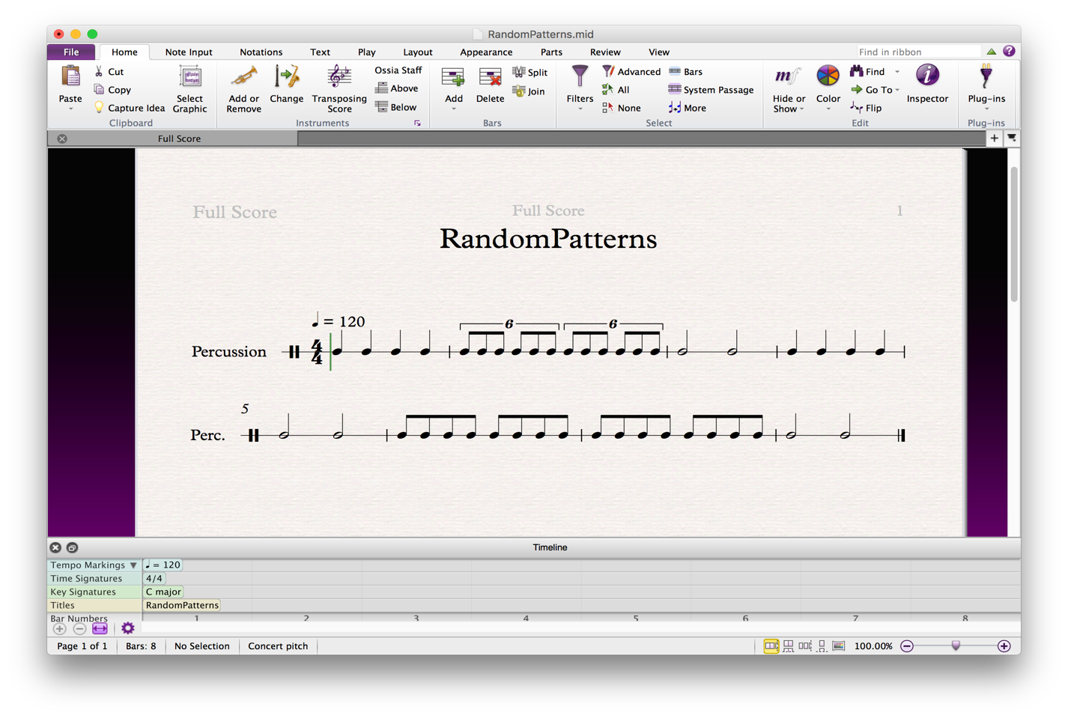Running the accuracy test will begin the metronome and await "A" and "L" key presses to play the notes.

The playback function will play the given midi file once and then stop. After any of the functions are run, the output of that function will be put into the GUI in a separate frame. Clicking the back button on the right side will return the user to the original screen:

